

|  |  |  |  |  |  |  |  |  |  |  |  |  |
| --- | --- | --- | --- | --- | --- | --- | --- | --- | --- | --- | --- | --- |
| To: | Parents/Carers | |  |  | | --- | --- | | **Gofynnwch Am:**  **Please Ask For:** | **Gaynor Davies** | | **Rhif Est:**  **Telephone No:** | **01443 744001** | | **Ffacs:**  **Fax:** |  | | **E-Bost:**  **E-Mail:** |  | | **Cylchlythyr:**  **Circular:** |  | |

Dear Parent/Carer,

|  |  |  |  |  |  |
| --- | --- | --- | --- | --- | --- |
| Fy nghyf:  My Ref: | GD/TM | Eich Cyf:  Your Ref: |  | Dyddiad:  Date: | 10th September 2020 |

**AUTUMN TERM PROVISION BREAKFAST** **CLUBS**

As you will be aware, schools within Rhondda Cynon Taf were intending to re-establish breakfast club provision from Monday 14th September. I am writing to inform you that regrettably, following health and safety reviews, it is not possible to safely re-open breakfast club provision on this date against a backdrop of recent rising COVID-19 cases within our community.

Following the receipt of extremely high level of applications for breakfast club provision and an assessment of school hall sizes, it is not going to be possible to safely ensure that children remain within their contact groups when attending breakfast club. The Council is keen to ensure that the provision of education is not compromised by potentially having large numbers of children needing to self-isolate due to contact groups not being maintained when attending breakfast club provision. We are planning to re-open provision on 28th September 2020 with a significantly reduced capacity. Places will be allocated on a ‘first come - first served’ basis based on the submitted applications and unsuccessful applicants will be notified by 5pm on 18th September 2020. Successful applicants will not be notified as places have been automatically reserved.

A further application process will be undertaken for the new Spring Term and parents will receive further details at the end of November 2020 of how to reapply on-line.

I am sure you will understand that the safety of your child is paramount in this decision. The position will be kept under review and I will write to you again with a further update in due course.

Thank you in anticipation of your continued support.

Yours sincerely,

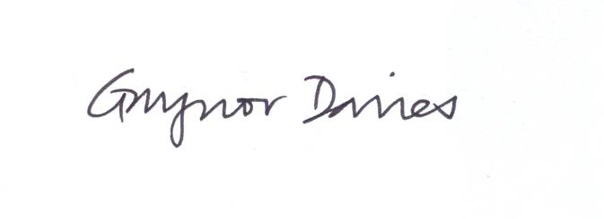

**Director of Education and Inclusion Services**