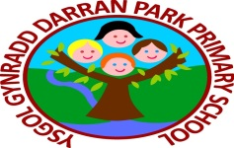 Healthy Helpers Meeting Minutes
Date: 26.10.22
Time: 2.30pm
Location: Bluebirds Classroom
In Attendance: Mr Ingram/ Mrs Davies
Mason, Ethan, Amelia, Darcee, Shane, Lydia

Topics of discussion: Healthy Halloween Treat

Required Action: Healthy helpers to research Healthy Halloween Snack ideas ready to share during our Halloween disco. Three different types of healthy snack to be on offer. Healthy Helpers to make the healthy snack on the day of the disco. Healthy helpers to make a picture evidence poster to share for Healthy Schools Award.

By Who: Healthy Helpers

Date of next meeting: 16.11.22

