A quick guide to using the ‘ActiveLearn’ website to access Maths homework games:

To access ActiveLearn go to www.activelearnprimary.com and log in.
Your username is your child’s first name and first initial of their surname, all in lowercase.
Your password is darran.
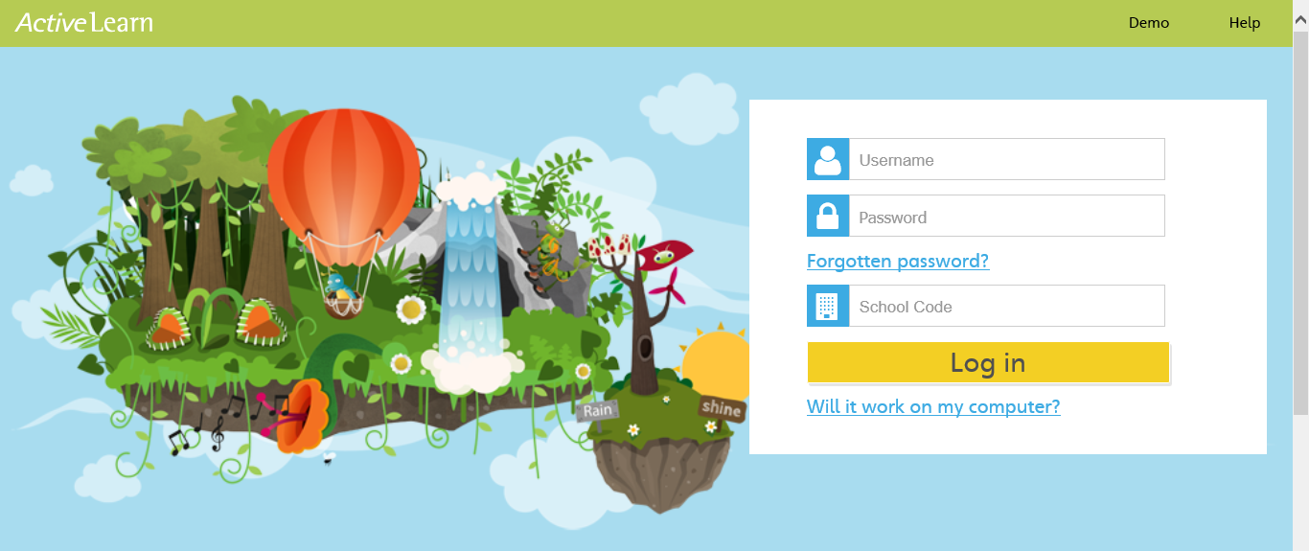
Our school code is ‘g6sq’.

Once you have logged in, you will see a screen similar to this:
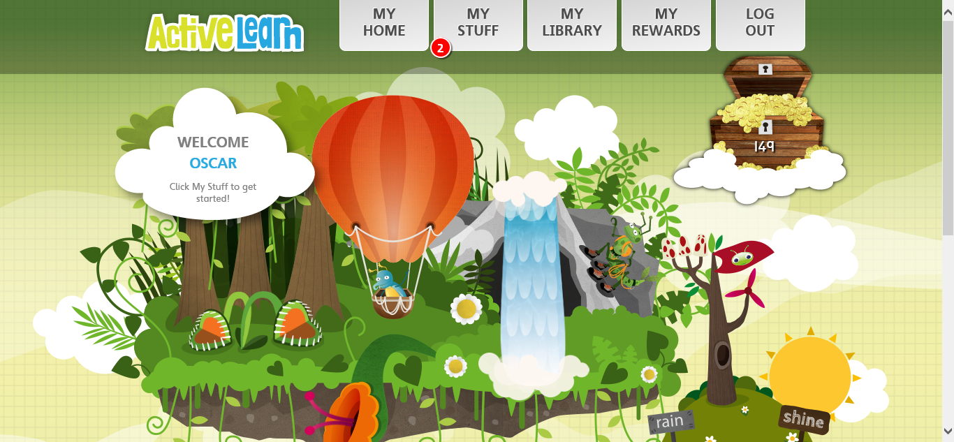

You use the grey buttons along the top to navigate the site.

Hovering the cursor over ‘My Home’ gives you the option to change the theme of your account (this will change how the website looks when you are logged in).

Clicking on ‘My Stuff’ will take you to games you have been set which haven’t been completed yet. When you have games you haven’t opened yet, you will have a red notification on this button.
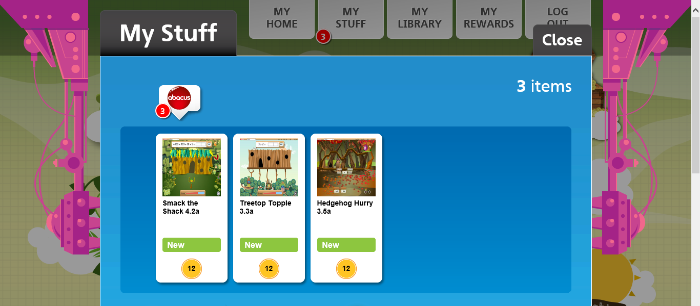
Click on a game to play it. Each game has 3 levels, bronze, silver and gold and gets harder as you go along. You must complete each level to unlock the next one.
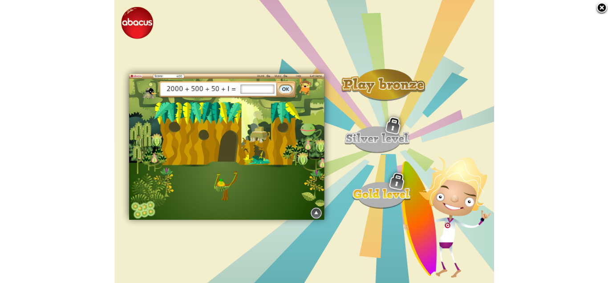
When you first click on each game, it will give you instructions of how to play. Make sure you read these so you know what to do! You can click on the speaker picture to have the instructions read out to you.
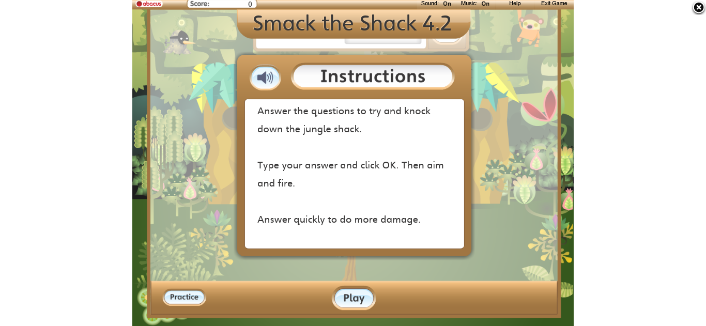

Once you have finished playing, click the ‘X’ in the top right corner to go back to the home page.

Clicking on the grey ‘My Library’ button on the home page will allow you to access all the games you have been allocated, including ones you have completed so you can go back and play them again at any time.
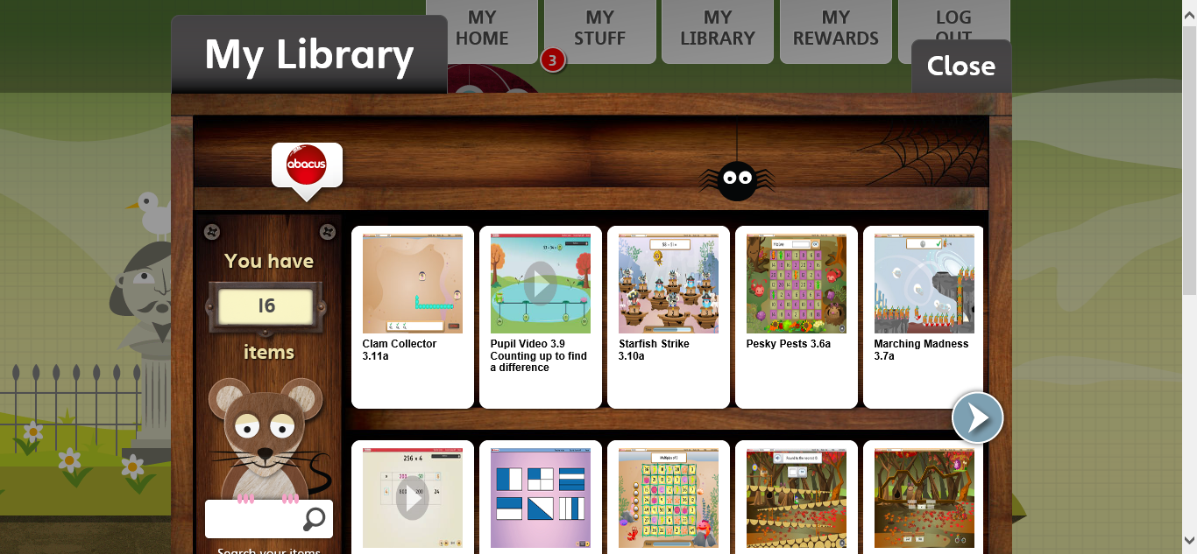

Clicking on ‘My Rewards’ lets you access The Pit Stop, Sticker Book, Skate Shack, The Game Zone and The Treehouse. Explore these areas once you have completed some games to collect your rewards and play bonus games.
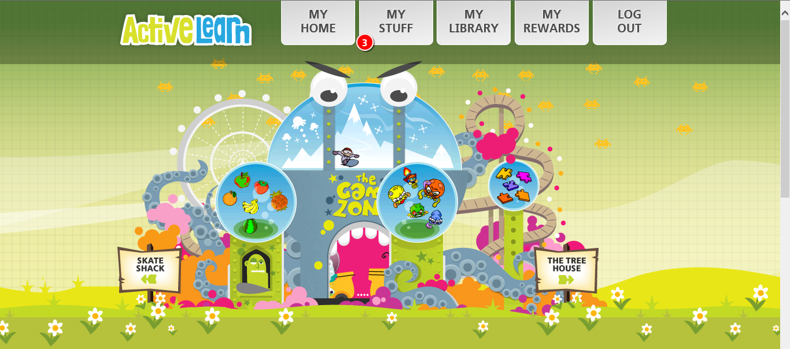

Have fun and practice your Maths skills as often as you can!

