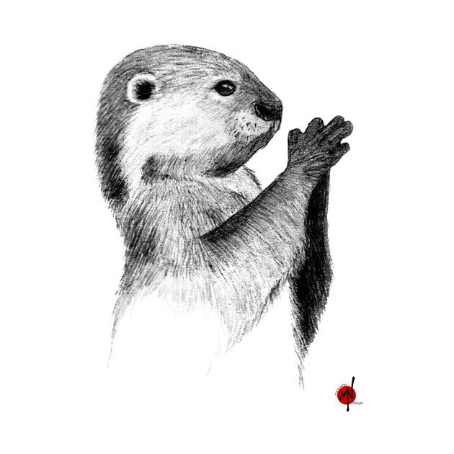

**Autumn Term**

Our inquiry this term involves the ‘Properties and Changes of Materials ‘and their ‘Impact on the Polar Regions of our Earth’ which is mostly science in nature.

Pupils will learn about the wider properties of materials and their uses including mixtures and how they can be separated using sieving, filtration and evaporation. They will study reversible and irreversible changes, and use common indicators to identify irreversible changes. Furthermore, pupils will investigate the characteristics and features of polar regions, including the North and South Poles, and includes a detailed exploration of the environmental factors that shape and influence them.

In **Science** we will be building scientific skills to investigate their ideas, in the inquiry we study.

In **Literacy**, we will be learning how to develop a range of quality vocabulary and sentences to write descriptions and conversations in order to develop a range of writing genres, including imaginative, explanation and biographical texts and learn to interrogate texts. Oracy tasks will be developed through the term.

**Numeracy** will be concerned with number, calculations, fractions, measurement and data, and will be applied across the curriculum.

We will revise and develop **Welsh** sentence patterns and vocabulary to develop their oracy, reading and writing. Pupils will have opportunities to develop their artistic skills

**Otters Year 5**

**2023/4**

**Autumn Term 2022**

**Reminders**

Jogging bottoms or leggings and trainers will be needed on Wednesday PE lessons

Fruit can be bought at break time for 30p

Reading books are to be returned weekly, even if the book hasn’t been completed, in order to check progress.

Homework will be given out generally on Thursday, to be completed and returned on Tuesday.

**Important Dates**

27th October – Break up for half term

Athletics after school club will begin on Thursday 21st September 3-4 pm.

**Reminders**

Please remember to check the school website and our twitter page to keep up to date with what is going on in school.

www.darranparkprimary.com @DarranPark